Exercise Push App on Bluemix with DevOps
1.Select node.js runtime on bluemix console page after logon to create node.js App.
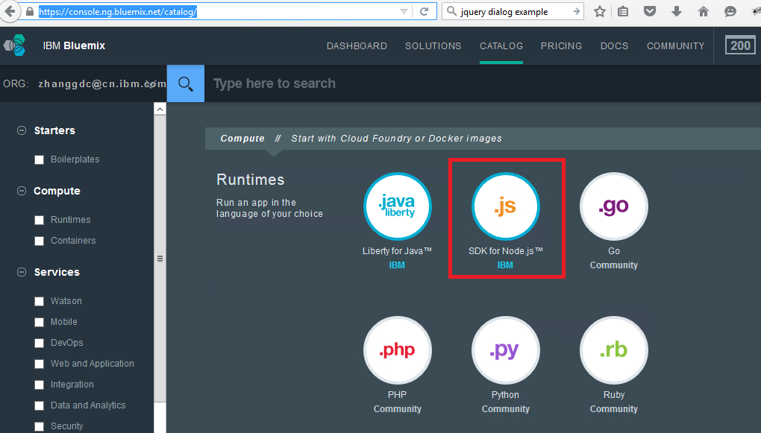
2.Input App name and click button “create” on Wizard page.
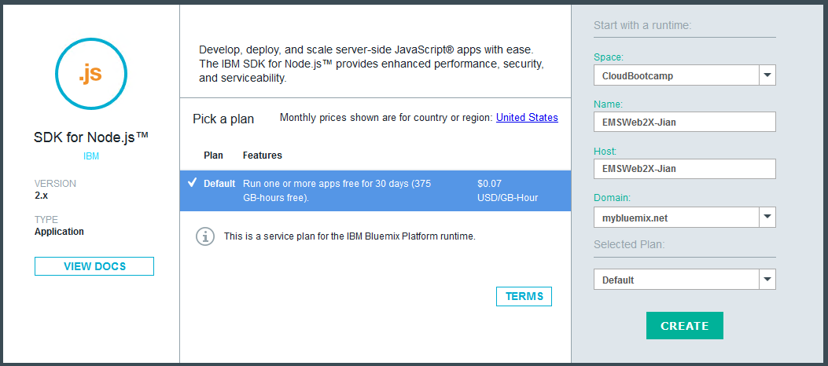

3.Click link “Add Git” on Overview page of App.
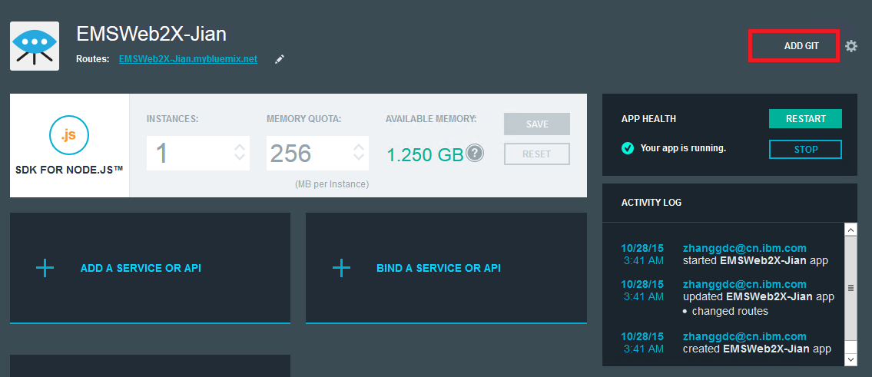
4. Leave option “Populate….” with empty and click button “CONTINUE” to create Git Repository .
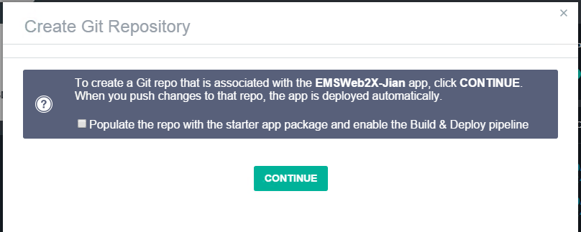
5.Click Button “EDIT CODE ” on Overview page of App to switch to Devops Console page.
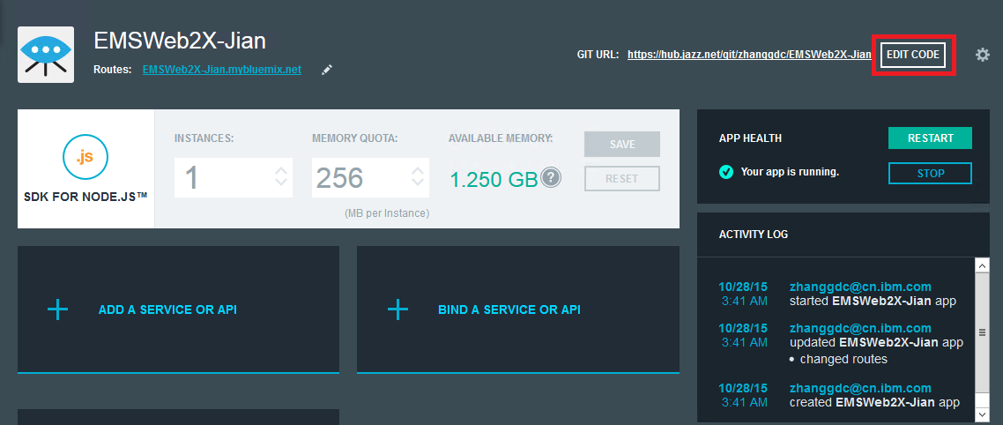
6.Import project zip file included all of files.
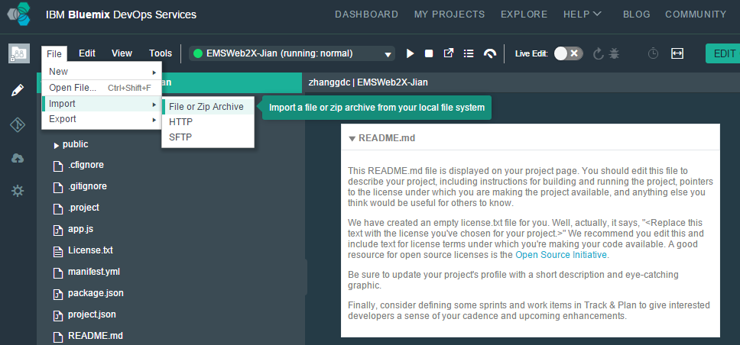
7.Switch to Git Repository Tab .
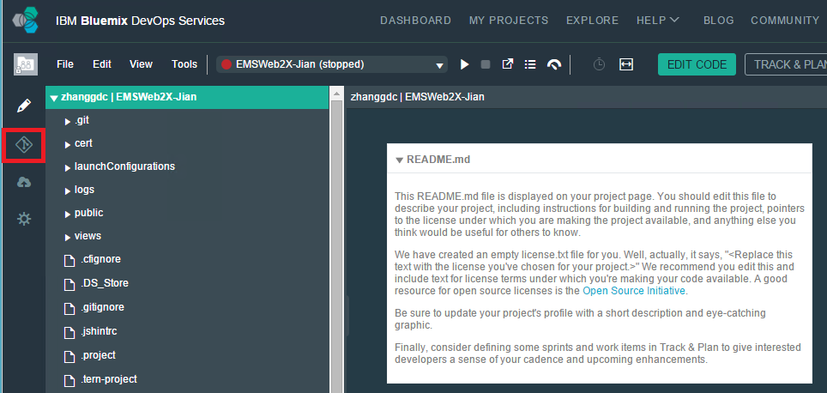

8. Commit changed source after click option “Select All” and input comment for update
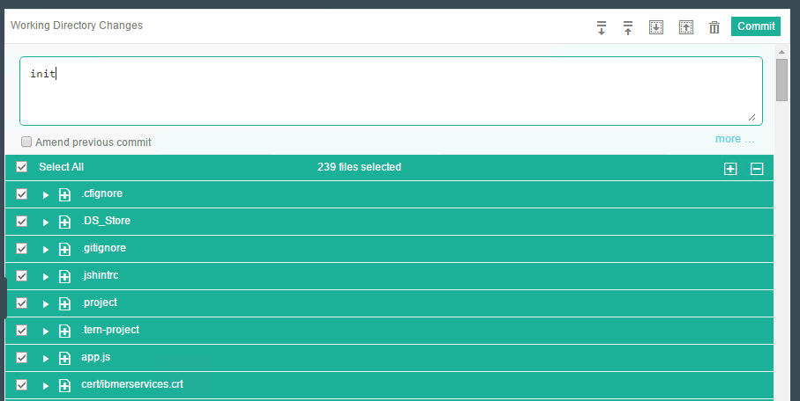
9.Push commits from your local branch into the remote branch.
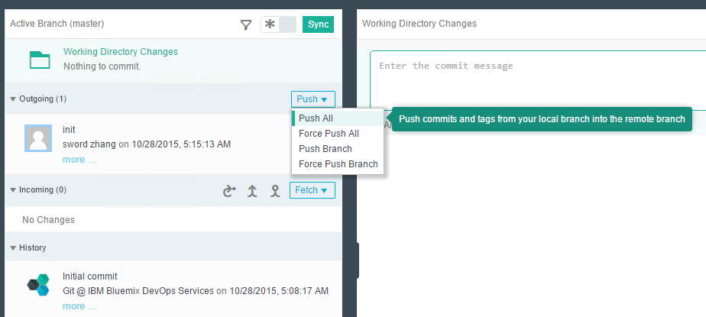
10.Switch to Build&Deploy view to config Build Stage.
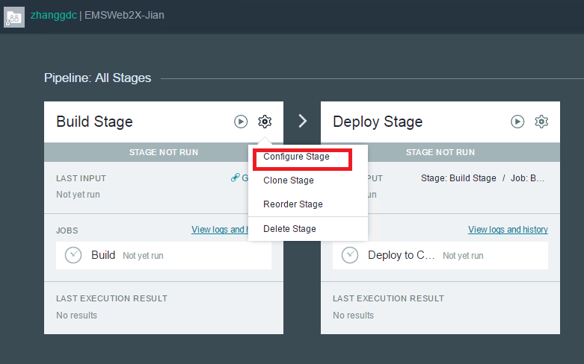
11.Change Builder Type to “npm”.
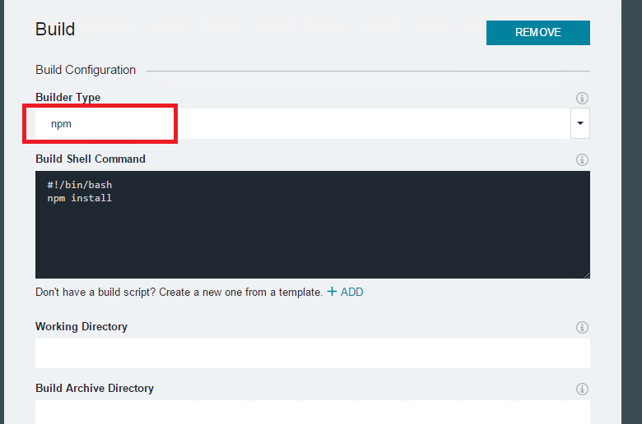
12.Start up Build Stage&Deploy Stage.
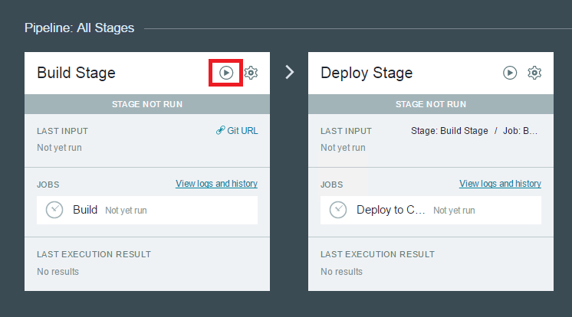
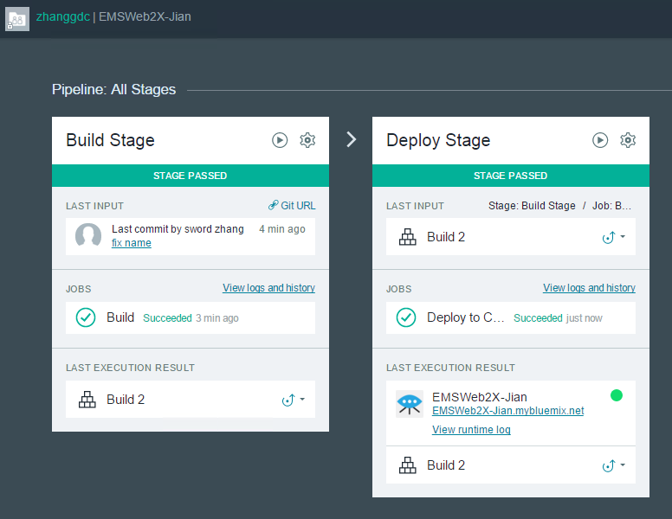
13. Access bluemix site after deploy successfully.
